**Because of its size and large scale, Korenskaya Fair is called now one of the main commercial grounds of our state. Here the representatives of government, business, community and clergy gather together, and their thoughts, consolidated efforts for the prosperity of the country are combined. Korenskaya Fair is also a demonstration of the economic viability of not only the individual regions, but of the entire nations. Last year the Fair was attended by officials and business delegations from 36 Russian regions and 28 countries of CIS and foreign countries, including Belarus, Moldova, Armenia, Uzbekistan, Kazakhstan, Azerbaijan, Ukraine, Italy, Bulgaria, Hungary, Austria, Germany, Greece, Slovak Republic, Serbia, Czech Republic, Egypt, Zimbabwe, Uganda, Tanzania the Socialist Republic of Vietnam, India, People Republic of China, Ecuador, Sri Lanka, El Salvador, Panama, Turkey and the representatives from the Republics of Donetsk, and Lugansk.**

**The achievements and innovations in industry, agriculture and many other industries are presented by both large companies and small and medium-scale business. The banks and insurance companies, educational and science institutions also present their products there. The completely exclusive things can be found here, but the most important thing is that you can establish new business contacts and find a business associate here.**

**Every year the dozens of agreements, protocols and contracts in different spheres of economics are signed as the results of the meetings and negotiations.**

**We invite you to take part in the XVIII Interregional Universal wholesale-retail fair «Kursk Кorenskaya Fair – 2018» which will be run from June, 7th till 10th 2018!**

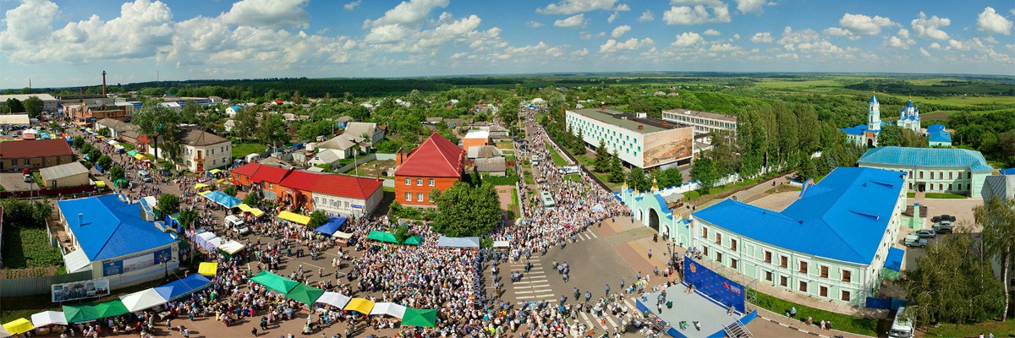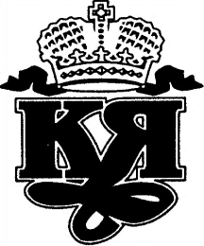

**КУРСКАЯ КОРЕНСКАЯ ЯРМАРКА**