Vlast Truda Plywood Plant, OJSC

ABOUT US 3
OUR STRATEGY 4
ADVANTAGES OF COOPERATION 5
OUR WORKING EXPERIENCE 7
OUR PRODUCTS 8

The Plywood Plant ‘Vlast Truda’ is one of the the oldest wood-processing enterprises in Russia. It was founded in 1858; the plant has risen from the artisan undertaking producing matches to the modern high-technology enterprise manufacturing plywood of general and special purpose.
The plant includes the full-scale manufacturing complex dealing with wood-processing – from pretreatment of the round wood to the turnout of the end product.
Our plywood possesses all useful properties of wood but besides it is not subject to checking; it is protected from moisture; it can take various bending shapes and it has dimensions convenient for fast mounting/dismounting and transportation.

The products of the company is the guarantee of quality, safety, ecological compatibility and development of our partners’ business in the fields of furniture making, construction, railway carriage manufacturing and mechanical engineering.

The policy of the company includes the following items:
- consumer orientation;
- implementation of innovations and modernizations;
- improvement of product quality;
- diversification of products;
- expansion of export and domestic markets;
- development of staff and corporate culture;
- lean production, stability and safety.

Over a number of years the company works closely with Moscow State Forest University and uses its scientific research results; the company owns Russian and international certificates proving the high quality of the manufactured products.
̶ Certificate FSC (FC-COC-643036, FC-CW-643036, Standards FSC-STD-40-004V.2.0, FSC-STD-40-005V.2.1)

- ISO 9001:2008
› The fire-hardened plywood has the following certificates:

- CARB- IKEA 15-07-06-01
̶ Applicable on passenger-carrying railway transport:

̶ Certificate of the River Register applicable on water transport;

› The products are tested by the international laboratories:

̶ ‘Laboratoire national de metrologieet d'essais’, File № F101177, Paris, France

▪ Standard: NF F16-101; 16-102 ;

▪ Decision: combustibility – Class M1, smoke emission – Class F1

̶ ‘Hardwood plywood & veneer association – Laboratory and testing service’, Test
No. T-10509, Reston, Virginia, USA

▪ Standard: ASTME 84, NFPA 255, UL 723. Flame spread index А (<_20) –
not spreading flame

▪ Decision: blind-end burning, carbonization up to 12 feet, flame spread index
Class A = 20

̶ Laboratory CIDEMCO (Tecnalia), Spain.

▪ Standards UNE EN 13823:2002, UNE EN ISO 11925:2202,

▪ Result B-s2, d-0.

̶ Deutsches Institute für Bautechnik (DIBt), Berlin, Germany

▪ The work is in progress on testing at International Institute of Building Industry and introduction of the materials potentially applicable in public places into the list. Obtaining an appropriate certificate will allow for exporting plywood both to Germany and the countries that use German standards.

The Company regularly participates in various foreign and Russian exhibitions, in particular:

̶ Bau Munich (Germany),

̶ Woodexpo (Moscow),

̶ Ligna Hannover (Germany),

̶ IMM Cologne (Germany),

̶ XYLexpo (Italy) and others.

› Awards and achievements of the Company:

̶ ‘Honorary Diploma of the Best Russian Exporter’ (awarded by the Ministry of Economic Development and Trade);

̶ The low-combustible plywood for railway carriage manufacturing is included in
the Program ‘100 Best Goods of Russia’ (Program of Federal Agency on
Technical Regulation and Metrology).

The Company works at the export market for more than forty years. The largest countries consuming its products are the following:
United States of America, Germany, Egypt, Turkey, Azerbaijan, Finland, Great Britain, Latvia, Estonia and Italy.
Sales geography is constantly expanding.

The volume of the export products is increasing; in 2015 it made up more than 60% of the total volume of the sold plywood.

The location of the Company in close vicinity to the federal highway and the railway station provides a possibility of regular deliveries both by automobile and railway transport.
The cooperation with the Company guarantees to our partners a successful conduct of business.

PLYWOOD ФК-Э, ФСФ-Э (INTERIOR, EXTERIOR)
((Technical Specifications) ТУ 5512-002-00255214-2000)
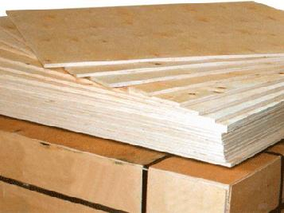
› Dimensions: length 1525 mm, width 1220 mm, 1525 mm, thickness from 3 to 18 mm, sanded and unsanded plywood

› Formaldehyde emission class - Е1 that complies with the requirements of the foreign consumers of plywood.

› Birch plywood for export is manufactured of birch rotary cut veneer and glued together of 3 and more ply-sheets. This plywood is applied in construction and furniture making.

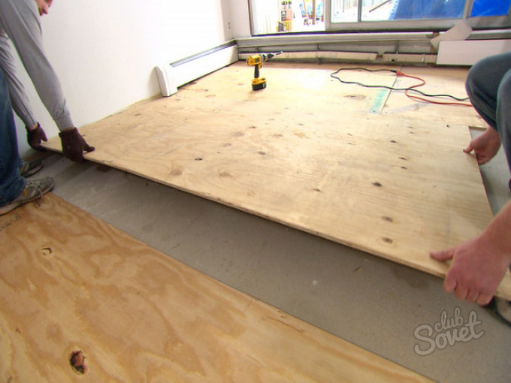

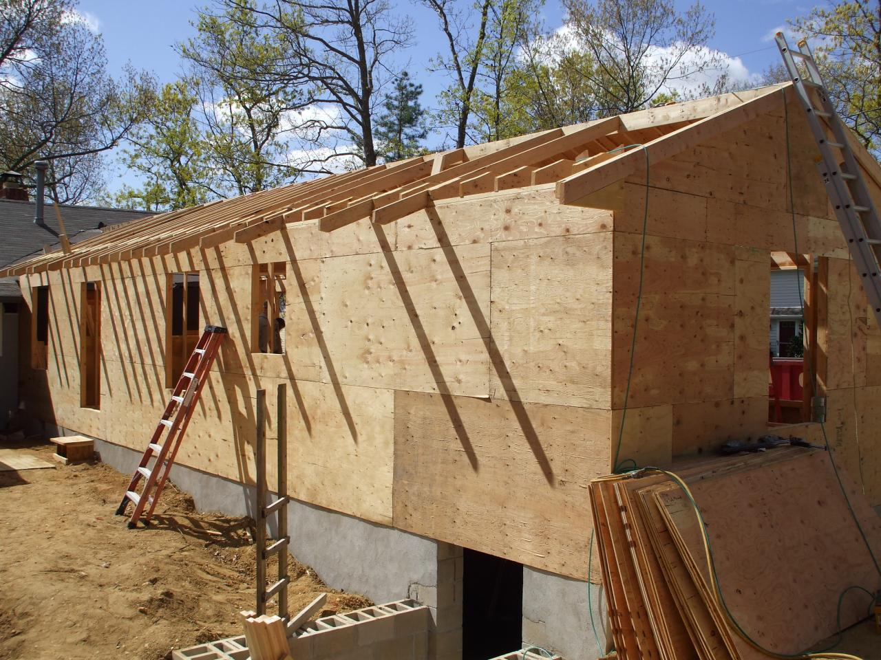

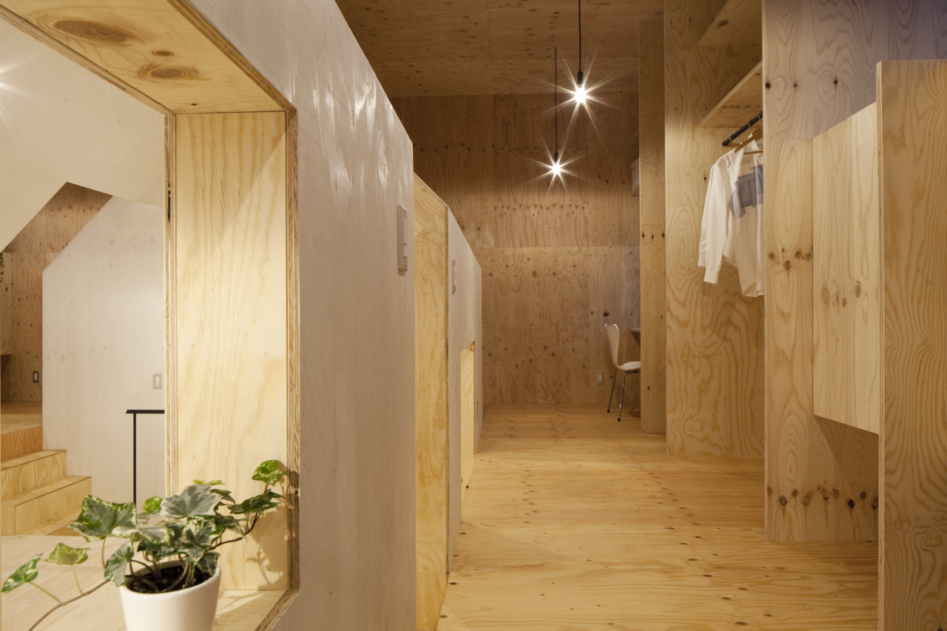

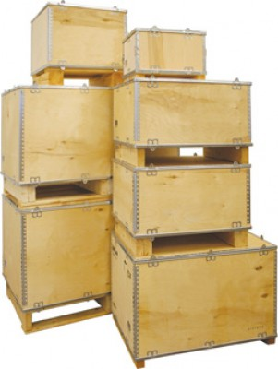
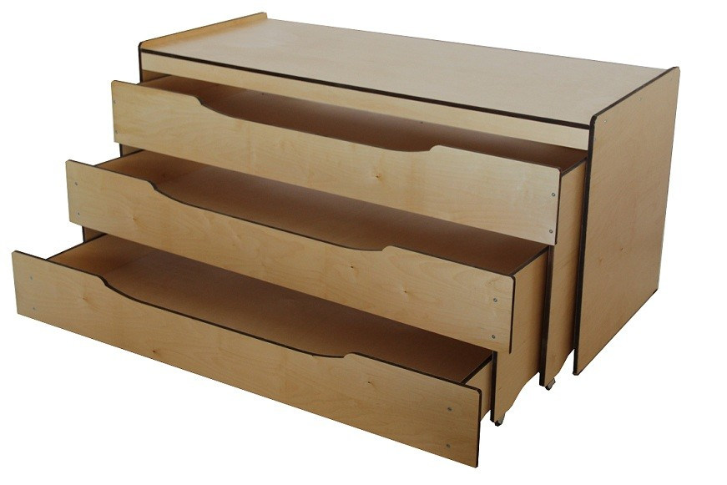

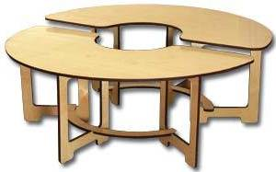

FIRE-HARDENED PLYWOOD ФСФ-ТВ (PlyGuard ®)
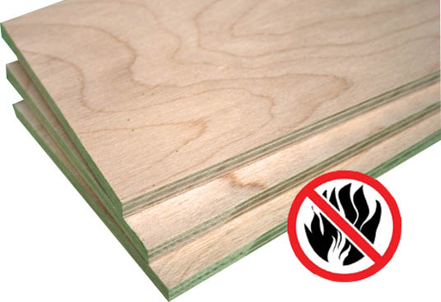
((Technical Specifications) ТУ 13-972-98)

› Dimensions: length from 1220 mm to 3150 mm, width up to 1830 mm, thickness from 4 mm to 30 mm.
› Formaldehyde emission class - Е1
› Plywood does not support burning. It is used in passenger-carrying railway carriage manufacture, traction rolling stock, crowded areas (concert halls, theatres, hospitals, hotels, offices and other objects).
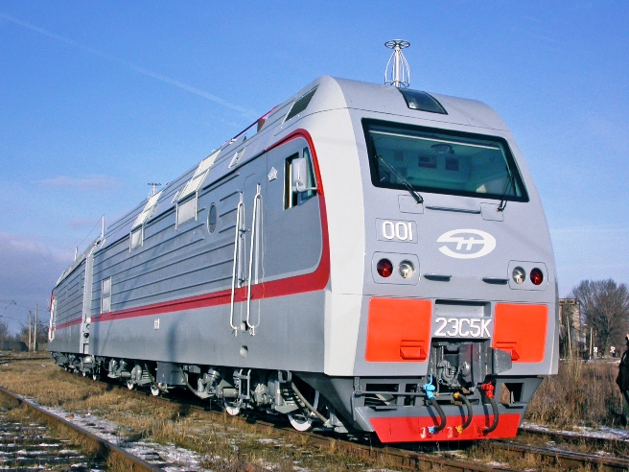
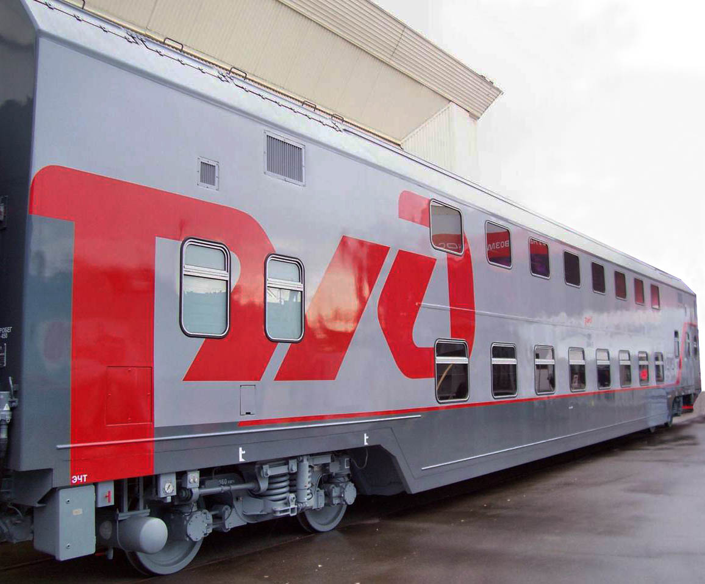

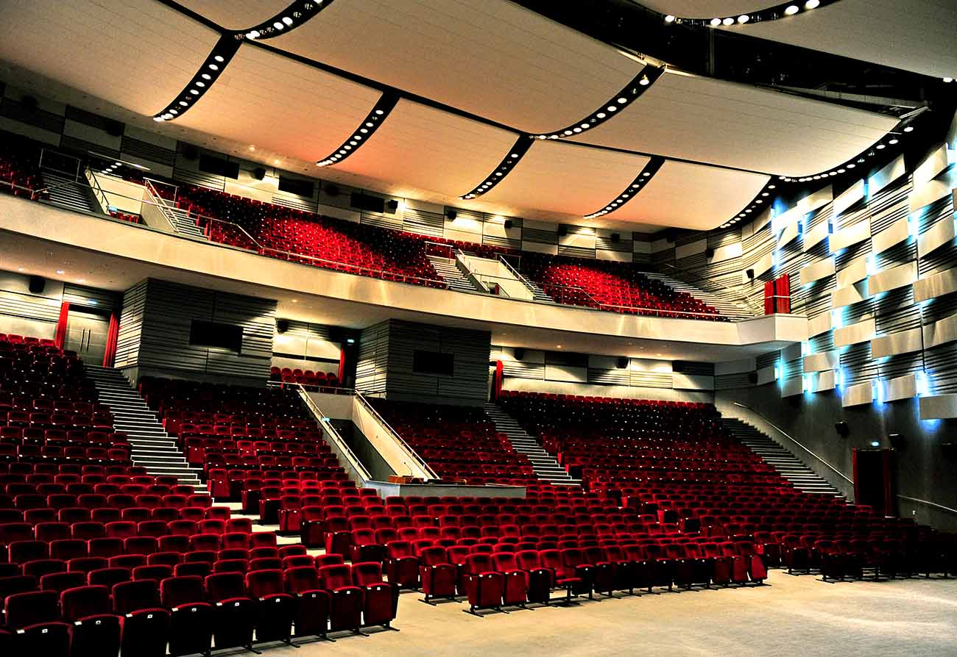

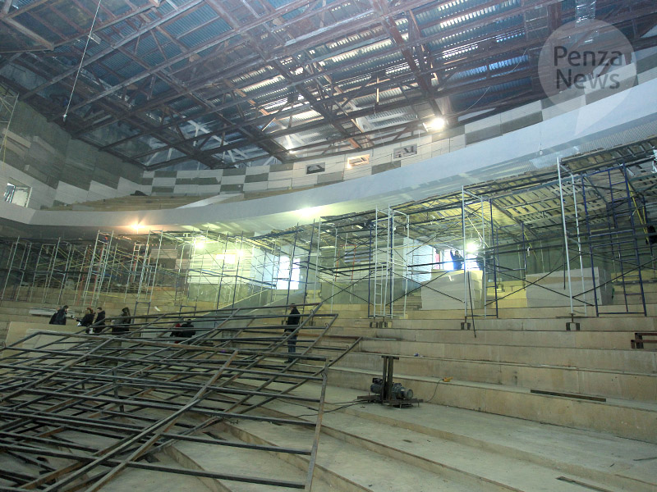

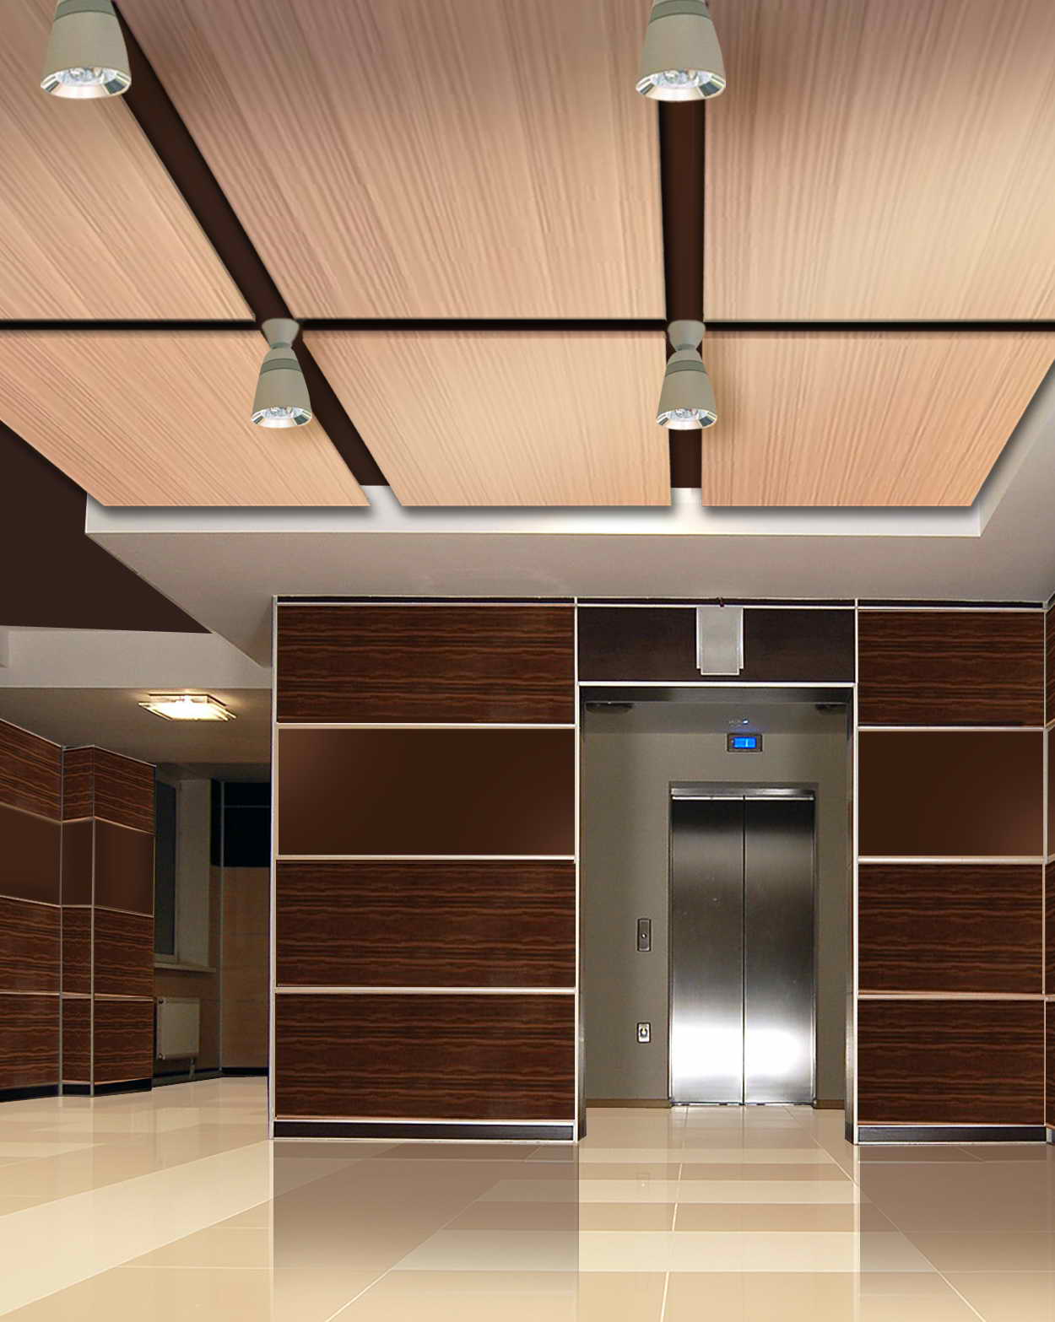

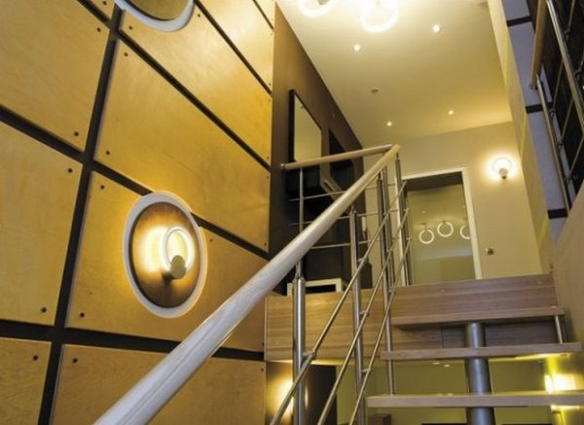

FIRE-HARDENED PLYWOOD FOR UNDERGROUND RAILWAY CARRIAGES ФСФ-ТМ ((Technical Specifications) ТУ 13-971-94)
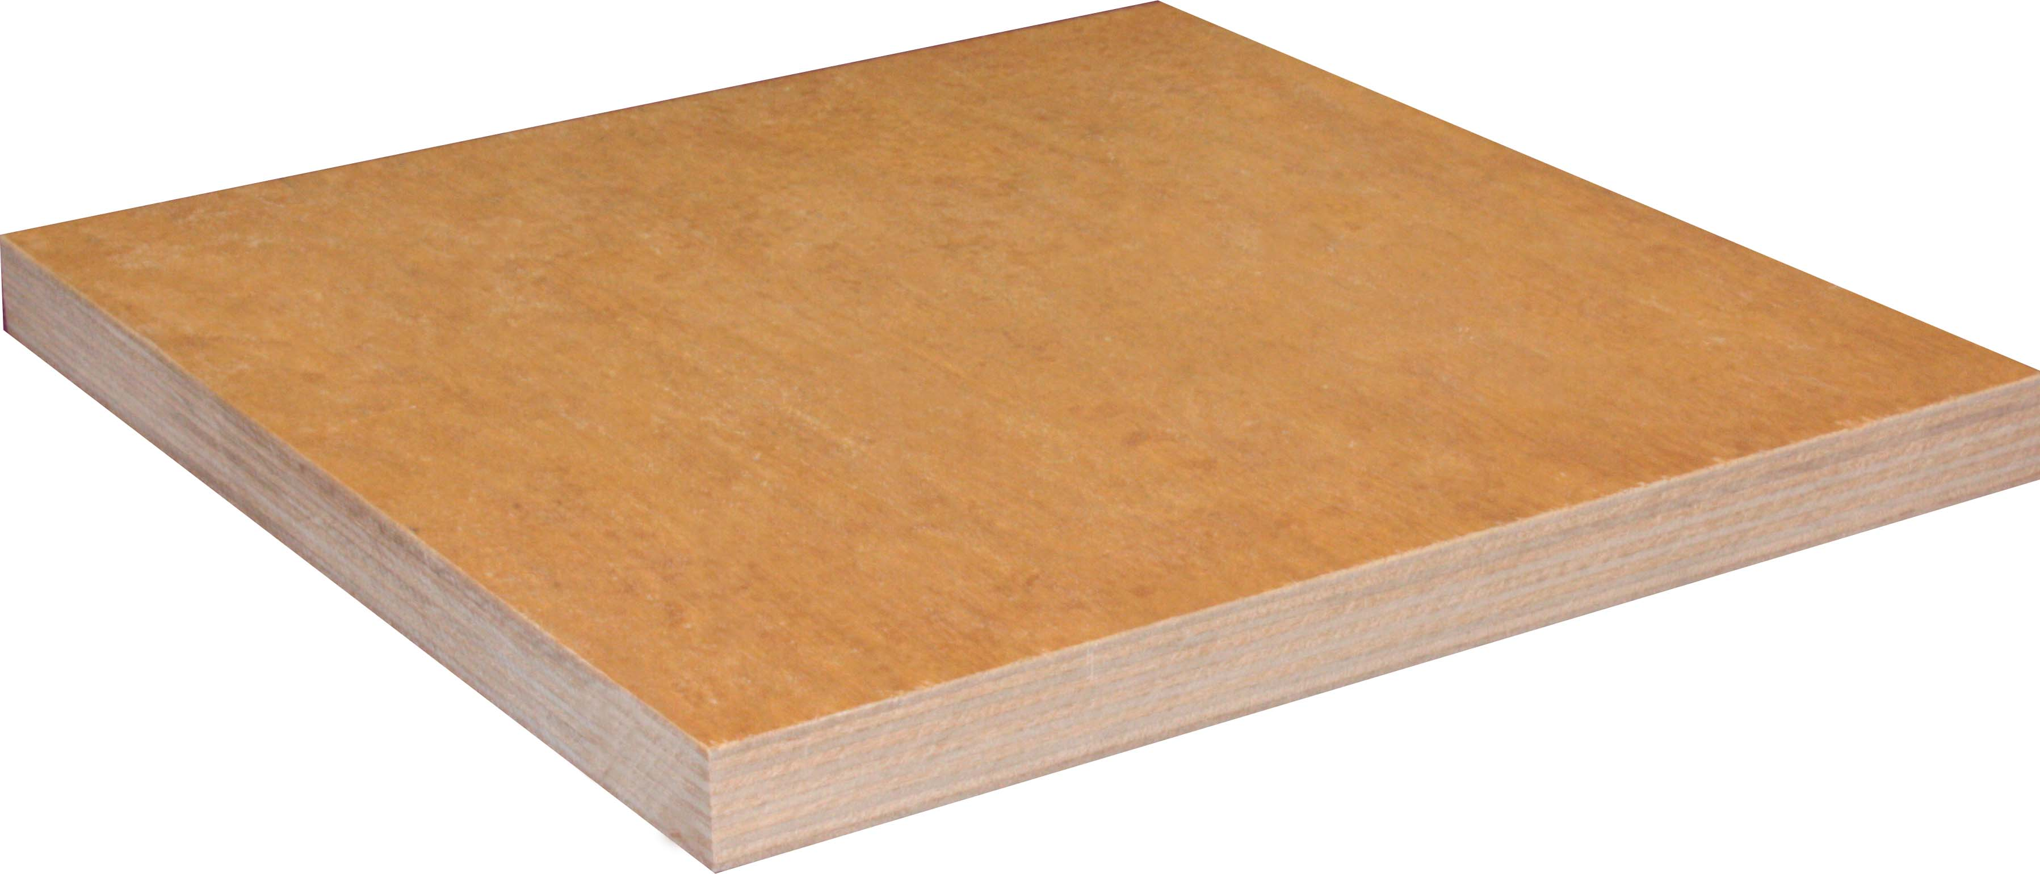
› Dimensions: length 1525 mm, width 1525 mm, thickness 10, 15, 20, 25 mm

› Certified for use in underground railway carriages. As for the physical and mechanical properties, this material has indices compared with the waterproof plywood of general purpose of ФСФ mark, and as for the fire hazard properties it ranks with the materials of low-combustible group, with moderate smoke-generating capacity, and it is moderately hazardous as far as it concerns the toxicity of combustion products.

› The version of plywood with the protective resinous coating that ensures the increased weather resistance and biostability of the material.
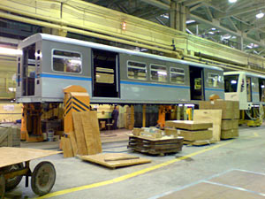

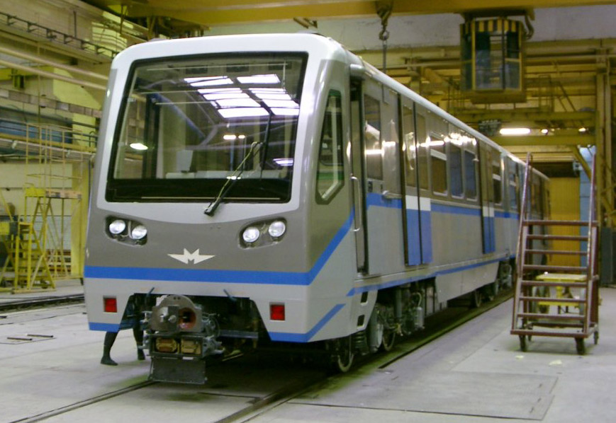

PLYWOOD ФВ-Т, ФВ-ТП
VIBRATION-ABSORBING, FIRE-HARDENED FOR RAILWAY CARRIAGE MANUFACTURING
((Technical Specifications) ТУ 5512-004-00255214-2007)
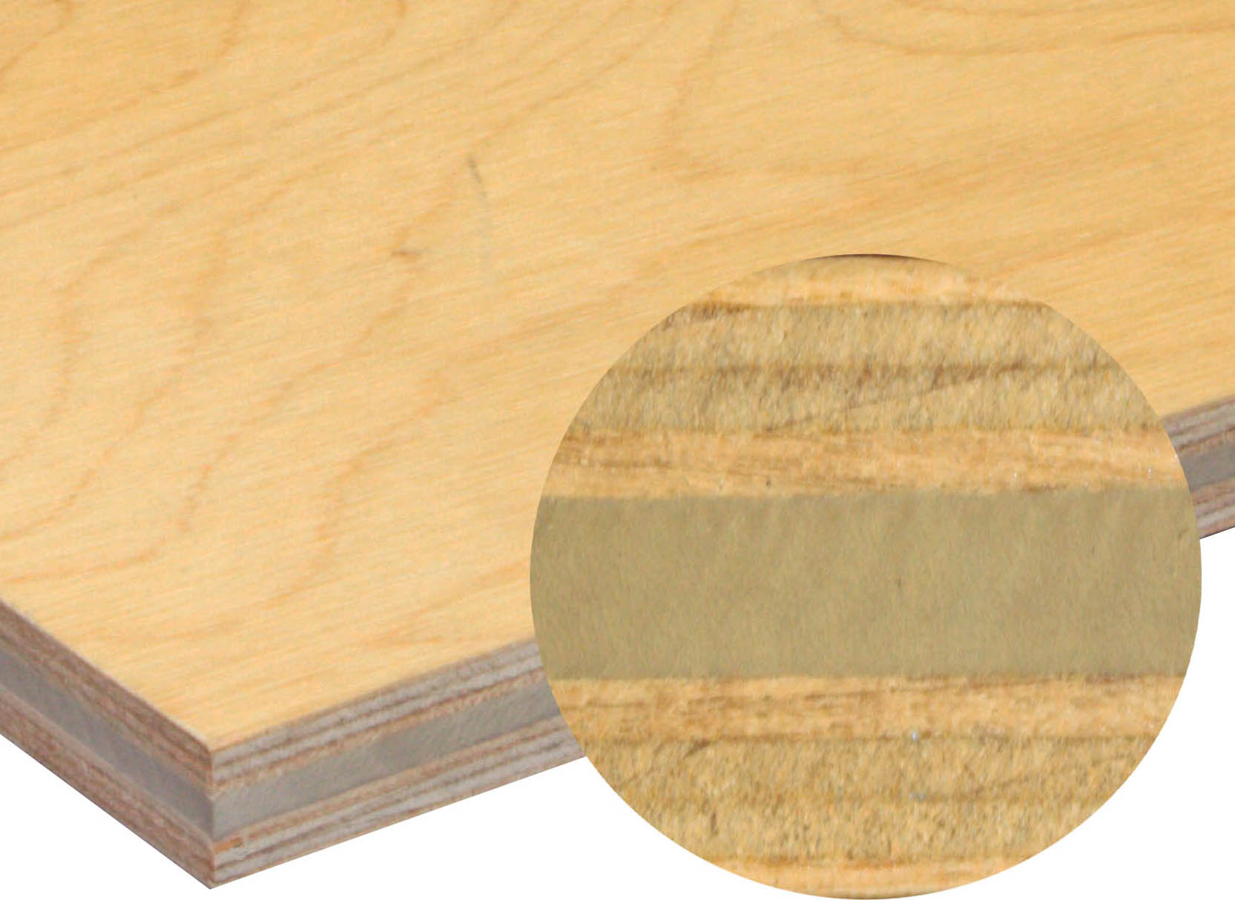
› Dimensions: length up to 3150 mm, width up to 1830 mm, thickness 15 mm

› This material was developed as a complex solution referring to fire safety and vibration insulation. As for the fire hazard standards, it ranks with the low-combustible group of materials, with the materials of low-combustible group, with moderate smoke-generating capacity, and it is moderately hazardous as far as it concerns the toxicity of combustion products.

› It reduces the harmful impact of vibration on humans and it also increases the noise insulation of the object.

› It is intended for use in mechanical engineering: passenger railway carriages, buses, sea craft and river craft and nuclear facilities.

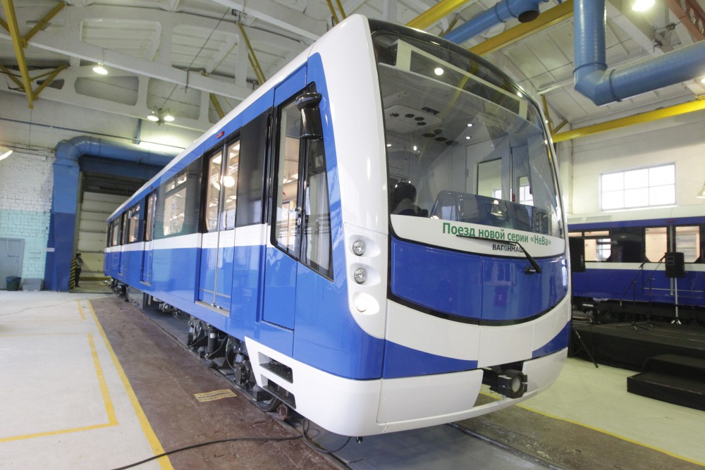

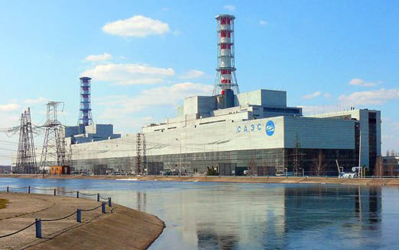

GLUED SOUNDPROOF FIRE-HARDENED PANELS
‘PLYGUARD ФОН»
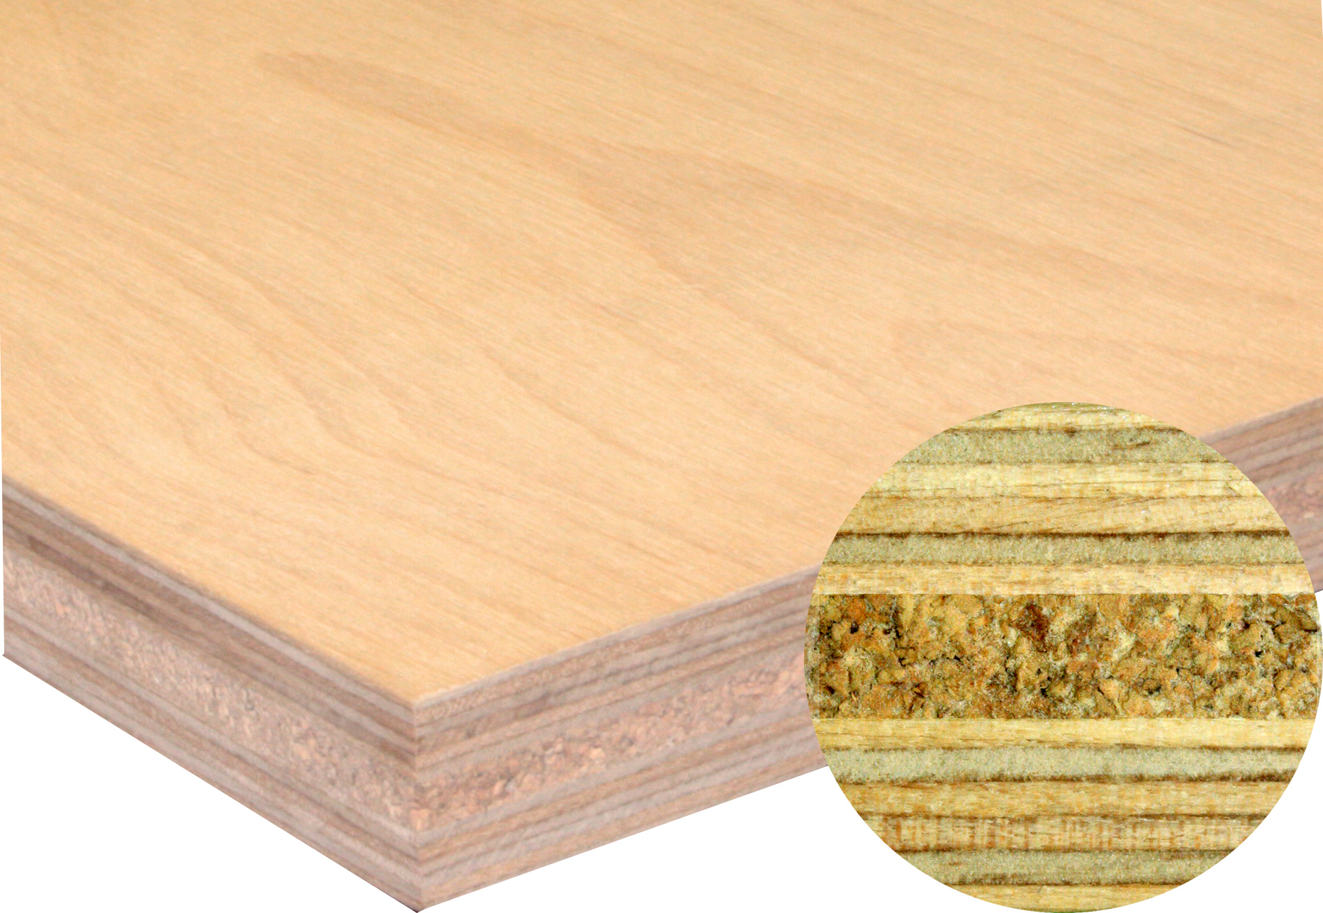
› Dimensions: length from 1200 mm to 3150 mm, width from 1200 mm to 1850 mm, thickness from 15 mm to 30 mm

› Complex solution on fire safety and noise insulation. These panels can be used as engineering or finishing materials in the industrial and civil construction: for finishing of sites with strict requirements of fire safety (crowded areas, escape routes, fire hazard areas); besides, the fire resistant properties allow using this material in passenger-carrying ground and marine transport.

› Flammability group G1, flame spread РП1
› Versions with perforation for better noise insulation of the premises are possible.

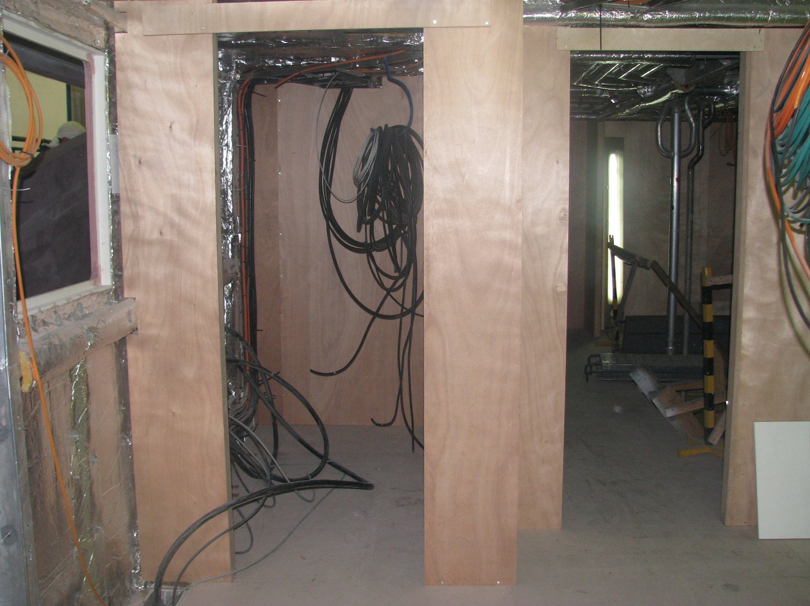

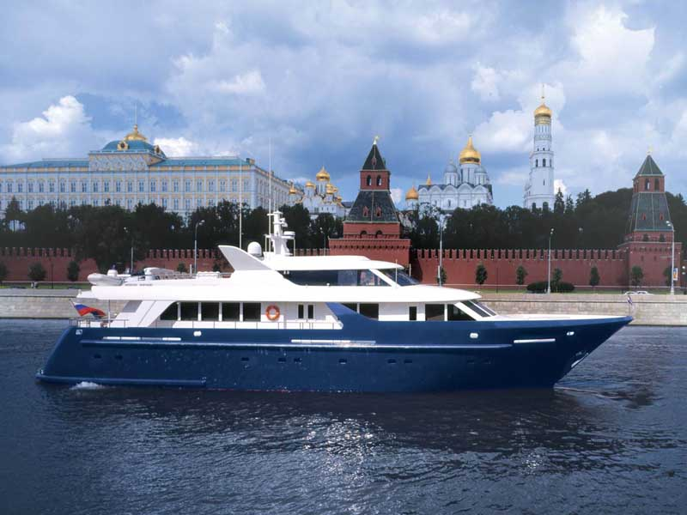

Curved laminated workpieces (lamellae, latoflexes) made of birch veneer
The orthopedic bases, bed carcasses are made using our products as well as sofas that due to their capacity to fit in with the body of a sleeping man provides for a healthy sleep and maintains the durability of mattress by way of effective reallocation of load.
Bending radiuses: 4000 mm and 8000 mm.
Coatings: lacquer (resin), or with decorative paper.
Name | Length, mm | Width, mm | Thickness, mm
Curved laminated work parts | from 415 to 1425 | from 25 to 170 | 8, 10, 12
Flat laminated work parts | from 440 to 1570 | from 35 to 170 | 8, 10, 12, 15
Bed underframes | from 200 to 1600 | from 35 to 70 | от 18 до 25
